The Disproportionate Effect of the COVID-19 Pandemic on Gig Workers

Throughout the regression process, two definitions of gig worker were defined. Definition one included any worker classified as self employed and unincorporated in the IPUMS CPS database. Definition two included any worker that usually worked less than 35 hours per week at their job(s). The results of the regression analyses, which controlled for the age, education level, race, citizenship status, marital status, industry, and occupation of each subject, revealed a negative trend in the hours worked by gig workers relative to non-gig workers. While the first definition gig workers saw negligible change in hours worked at worst and positive change at best, the second definition gig workers continuously experienced losses in hours worked from February to April 2020. The regression coefficient of these second definition gig workers fell from an already substantial -16.89 in February to -37.3 in April. This suggests that gig workers in the United States experienced a more severe economic impact from COVID-19 compared to non-gig workers, losing a disproportionate amount of hours of work relative to their peers. The tabulations used the first two gig worker definitions and added a third definition, which was any subject with multiple jobs. Across all three of these definitions, the plots reflected the same trend found in the regressions; there was a negative impact on the hours worked of gig workers relative to their non-gig worker peers.

Definition 1: Gig Worker defined as worker class 13 (self employed not incorporated), Non Gig is everything else

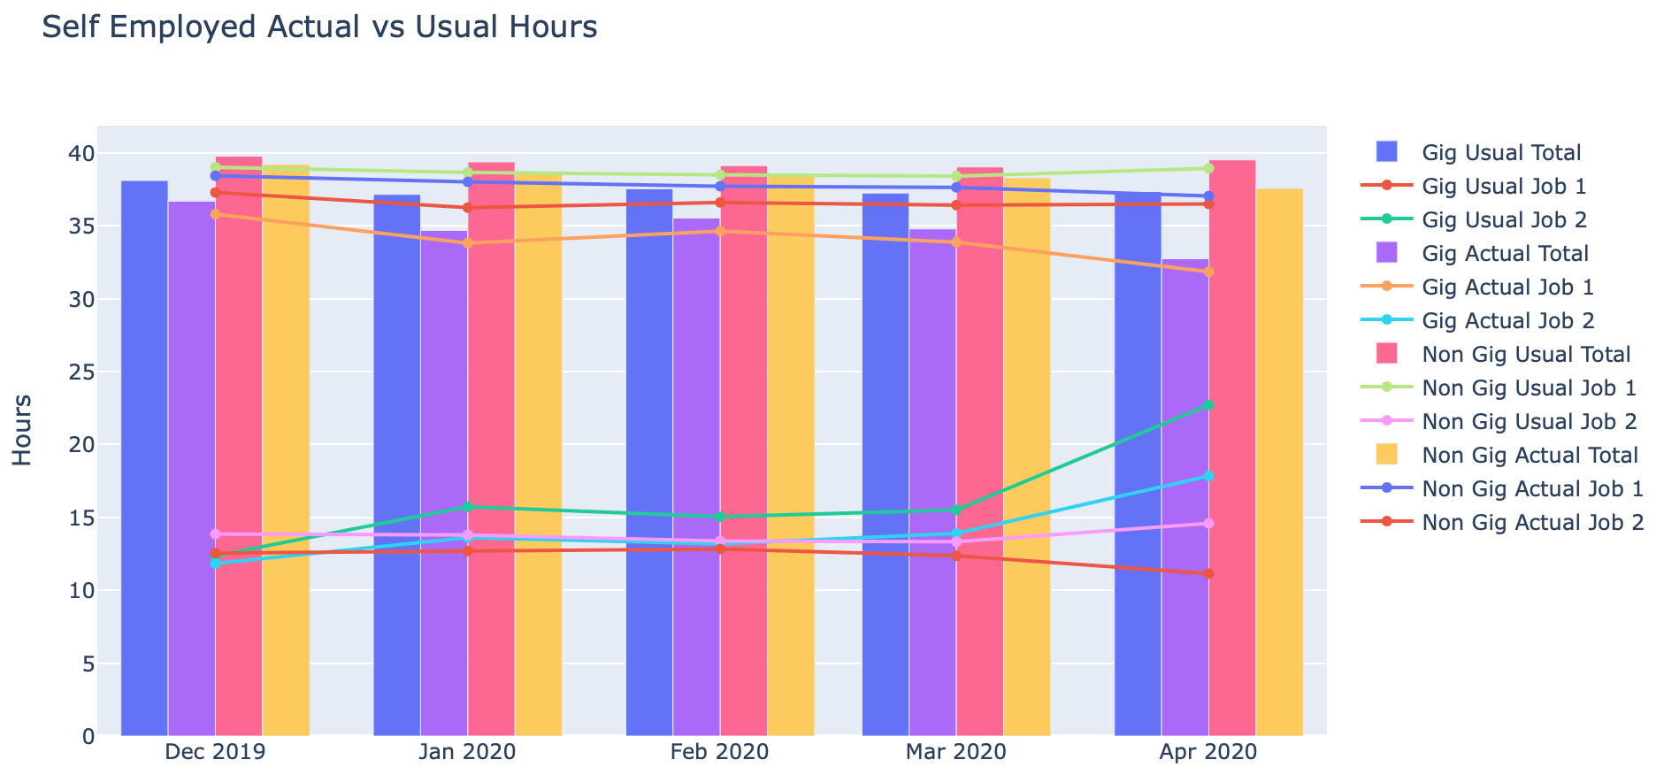

These first two plots show the same picture in different lenses to compare the effect of the COVID-19 pandemic on Gig workers as compared to more traditional occupations. In this first definition Gig workers are identified based on the worker class variable in the IPUMS CPS data, where 13 represents workers who are self-employed and not incorporated. The CPS data has been filtered to include only workers who enter their first or fifth month in sample in December or January, which gives 1,814 Gig workers and 55,822 non Gig workers. The second plot clearly indicates that Gig workers have been more heavily affected in each month as the discrepancy between usual and actual hours work grew with each month.

Definition 2: Gig Worker defined as part time workers (usual hours 1 and 2 each < 35), Non Gig is usual hours 1 >= 35

This next pair of plots corresponds to the second definition used to classify Gig workers, where part time workers who work less than 35 hours at each job are considered Gig workers. This definition yielded 408 Gig workers and 57,228 non Gig workers. The plots exhibit a similar behavior to those of the first Gig worker definition where non Gig workers experience minimal decreases in hours worked until the end of March and Gig workers see significant reductions in their hours worked by March. The main discrepancy between these results and the previous results is that Gig workers are more resilient until February seeing a difference of less than one hour between usual and actual hours worker; however the effects of the virus are seen in full force in the end of February and into March.

Definition 3: Gig Worker defined as having more than one job, Non Gig is one job

The third definition considers those who work multiple jobs to be Gig workers, which provides a set of 1,778 Gig workers and 55,858 non Gig workers. The trend of these plots is similar to the previous results although when defining Gig workers in this manner the effects of the pandemic appear to be more significant than in the previous cases. Similar to the part time workers the effect seems to be consistent and stagnant until March where the gap between usual and actual hours worked widens to over 8 hours. It is also worth noting that Gig workers under this definition work significantly more hours than those classified under the previous definitions with a total usual hours worked around 50 hours for each month compared to roughly 35 hours a week for the other two. These results do however mirror those of the previous definitions with respect to the effect on the workers’ first and second jobs. In each case the first job suffers the brunt of the impact whereas the hours worked from the second job remains stagnant or increases to make up for the loss of hours at the first job

Age Brackets 20-35, 36-50, 51+

Definition 1 (self employed not incorporated)

When dividing the data sets further into age brackets, the effect on non Gig workers is consistent for each group while the 36-50 and 51+ groups for Gig workers are similar but the 20-35 group saw a rebound in March where they were able to find more hours while the other two groups saw significant drops in hours at the same time. This can likely be attributed to the fact that younger workers are more comfortable to continue working and risking exposure to the virus. The sizes of the sets are as follows: for Gig workers 20-35 there are 270 workers, 568 for 36-50, and 986 workers aged 51 and over. For non Gig workers 20-35 there are 11,317 workers, 10,601 for 36-50, and 20,983 over 51.

Definition 2 (part time)

The results from the second definition are similar showing the same trend among all non Gig groups and the 20-35 age group is no longer better off than the other two nor does it show the rebound that the group experienced in the previous plot. In this case the Gig workers aged 20-35 consists of 157 workers, 96 for 36-50, and 140 over 50. Non Gig workers have 11,430 workers 20-35, 11,073 aged 35-50, and 21,829 older than 50.

Definition 3 (multiple jobs)

The third definition is similar to the previous two in terms of non Gig workers and the Gig worker groups behave similarly as well. Again, the youngest age group does not see the same rebound in March but they do still manage to fare significantly better than the older age groups. There are 559 Gig workers in the 20-35 range, 637 that are 35-50, and 595 over 50. This compared to 11,028 non Gig workers 20-35, 10,532 35-50, and 21,374 50 and over.

Metro Area

Definition 1 (self employed not incorporated)

Whether or not the worker lived in a metro area had little impact on both Gig and non Gig workers under the first definition. Gig workers in metro areas were affected slightly more significantly seeing an additional hour of work lost compared to those not in metro areas. There were 1,357 Gig workers living in metro areas compared to 430 not in metro areas, and 44,904 non Gig workers in metro areas as opposed to 10,345 not in metro areas.

Definition 2 (part time)

The second definition of Gig workers showed those in metro areas were affected far more severely than those outside metro areas. Non Gig workers were consistent with similar behavior regardless of whether or not they reside in a metro area. This sample yielded 330 Gig workers in metro areas and 73 outside of metro areas while there are 45,931 non Gig workers in metro areas and 10,702 outside metro areas.

Definition 3 (multiple jobs)

Living inside a metro area has little effect on Gig workers and non Gig workers when defined as those with multiple jobs. Gig workers in metro areas did finish March with an extra hour lost but the trend is generally the same for those inside and outside metro areas. Under this definition there are 1,375 Gig workers inside metro areas and 388 outside compared to 44,886 non Gig workers in metro areas and 10,387 not in metro areas.

Hard Hit State (more deaths than average state)

Definition 1 (self employed not incorporated)

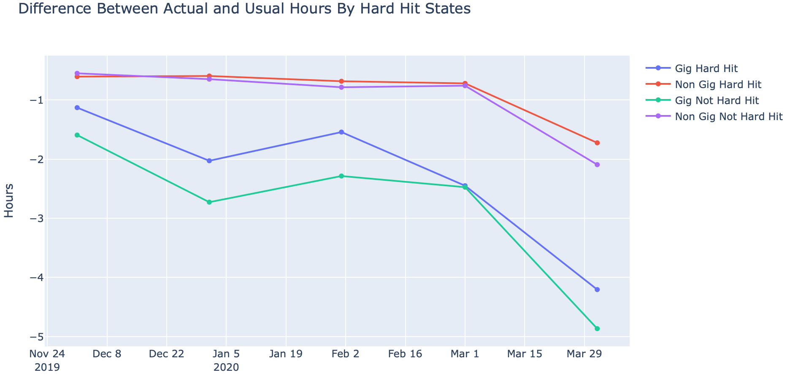

With Gig workers defined as self-employed not incorporated there is little impact on Gig and non Gig workers from living in a hard hit state. In both cases the hard hit states are within an hour of work lost of the states that did not see as many deaths from the virus. There were 651 Gig workers in hard hit states and 1,163 that were not compared to 21,869 non Gig workers in hard hit states and 33,953 not in hard hit states.

Definition 2 (part time workers)

The second definition also shows those in hard hit states have experienced similar trends to those not in hard hit states for both Gig and non Gig workers with Gig workers not in hard hit states suffering slightly more. The sample size of Gig workers in hard hit states is 164 and 244 not in hard hit states while there are 22,356 non Gig workers in hard hit states and 34,872 in states that were less affected.

Definition 3 (Multiple Jobs)

Under the third definition the behavior is also similar whether the worker lives in a hard hit state or not for both Gig and non Gig workers. Again, the Gig workers in states that were not hard hit lost an additional hour of work compared to their counterparts in hard hit states. There are 628 Gig workers in hard hit states and 1,150 not in hard hit states, compared to 21,892 non Gig workers in hard hit states and 33,966 elsewhere.

Education

Definition 1 (Self employed not incorporated)

The Gig workers were hurt the most regardless of education level with those with Graduate degrees or Associate degrees seeing the greatest decrease in hours worked. Every category of education level for Gig workers exhibited a similar trend but these two groups ended March having lost an addition one to two hours of work. Gig workers with some high school finished March with a significant recovery that left them far better off than Gig workers with more education. There are 183 Gig workers with some high school education, 832 with some college and high school, 227 with an Associate degree, 446 with a Bachelor’s degree, and 236 with graduate experience. This compared to 16,986 non Gig workers with some high school, 21,147 with high school and some college, 5,072 with an Associate’s degree, 9,827 with a Bachelor’s degree, and 5,608 with graduate school.

The second definition using part time workers as Gig workers again shows those with an Associate degree being affected the most of any other group by a significant margin. The behavior of each group is similar until March where Gig workers with an Associate degree or Bachelor’s degree see their hours worked fall further than any other group. Again it is the workers with some high school education that withstood the pandemic better than any other group of Gig workers. There are 19 Gig workers with some high school, 177 with high school and some college, 46 with an Associate degree, 106 with a Bachelor’s, and 71 with graduate school. This compared to 17,150 non Gig workers with some high school, 21,802 with high school and some college, 5,253 with an Associate degree, 10,167 with a Bachelor’s degree, and 5,773 in graduate school.

Definition 3 (multiple jobs)

The third definition of Gig workers also sees those with an Associate degree being impacted the most although regardless of the level of education, taking Gig workers as those working multiple jobs the trend is relatively consistent. The Gig workers see a significant recovery in February but lost additional hours in March although they still finished the period better than any other Gig worker group. In this case there are 63 Gig workers with some high school, 661 with high school and some college, 249 with an Associate degree, 530 with a Bachelor’s degree, and 355 with graduate experience. As opposed to non Gig workers, which consist of 17,106 with some high school, 21,318 with high school and some college, 5,050 with an Associate degree, 9,743 with a Bachelor’s degree, and 5,489 with graduate school.

Race

Definition 1 (Self employed not incorporated)

When separating the data by race Black and White Gig workers see the largest drop in hours and follow similar trends with Hispanic workers showing similar effects but managing not to lose as many hours. Asian Gig workers managed to withstand the pandemic better than any other group never losing much more than an hour of work. There are 1,594 White Gig workers, 104 Black, 83 Asian, and 232 Hispanic compared to 44,690 White non Gig workers, 5,819 Black, 3,381 Asian, and 8,463 Hispanic.

Definition 2 (Part time)

Using the part time definition Asian Gig workers fare better than any other group including non Gig workers at some points. The other three groups of Gig workers behave more closely to each other with Black Gig workers being impacted the most. There are 347 White Gig workers, 33 Black, 15 Asian, and 54 Hispanic under this definition compared to 45,937 White non Gig workers, 5,890 Black, 3,449 Asian, and 8,641 Hispanic.

Definition 3 (Multiple Jobs)

The third definition again shows Black Gig workers as the most adversely affected with all four categories of Gig workers behaving similarly. Asian workers were affected the least followed by White gig workers and then Hispanic. There were 1,466 White Gig workers, 181 Black, 79 Asian, and 193 Hispanic while there were 44,818 White non Gig workers, 5,742 Black, 3,385 Asian, 8,502 Hispanic.

Immigrant Status

Definition 1 (Self employed not incorporated)

When considering immigrant status and the first definition using self-employed not incorporated workers, naturalized Gig workers are impacted most whereas illegal immigrants and citizens experience similar impacts. Illegal immigrants were able to outperform all other groups through January but quickly lost hours to be comparable to the other Gig workers. There are 1,536 Gig workers that are citizens, 149 that are naturalized, and 132 that are illegal immigrants, as opposed to 49,583 non Gig workers who are citizens, 3,182 naturalized, and 3,194 illegal immigrants.

Definition 2 (Part time)

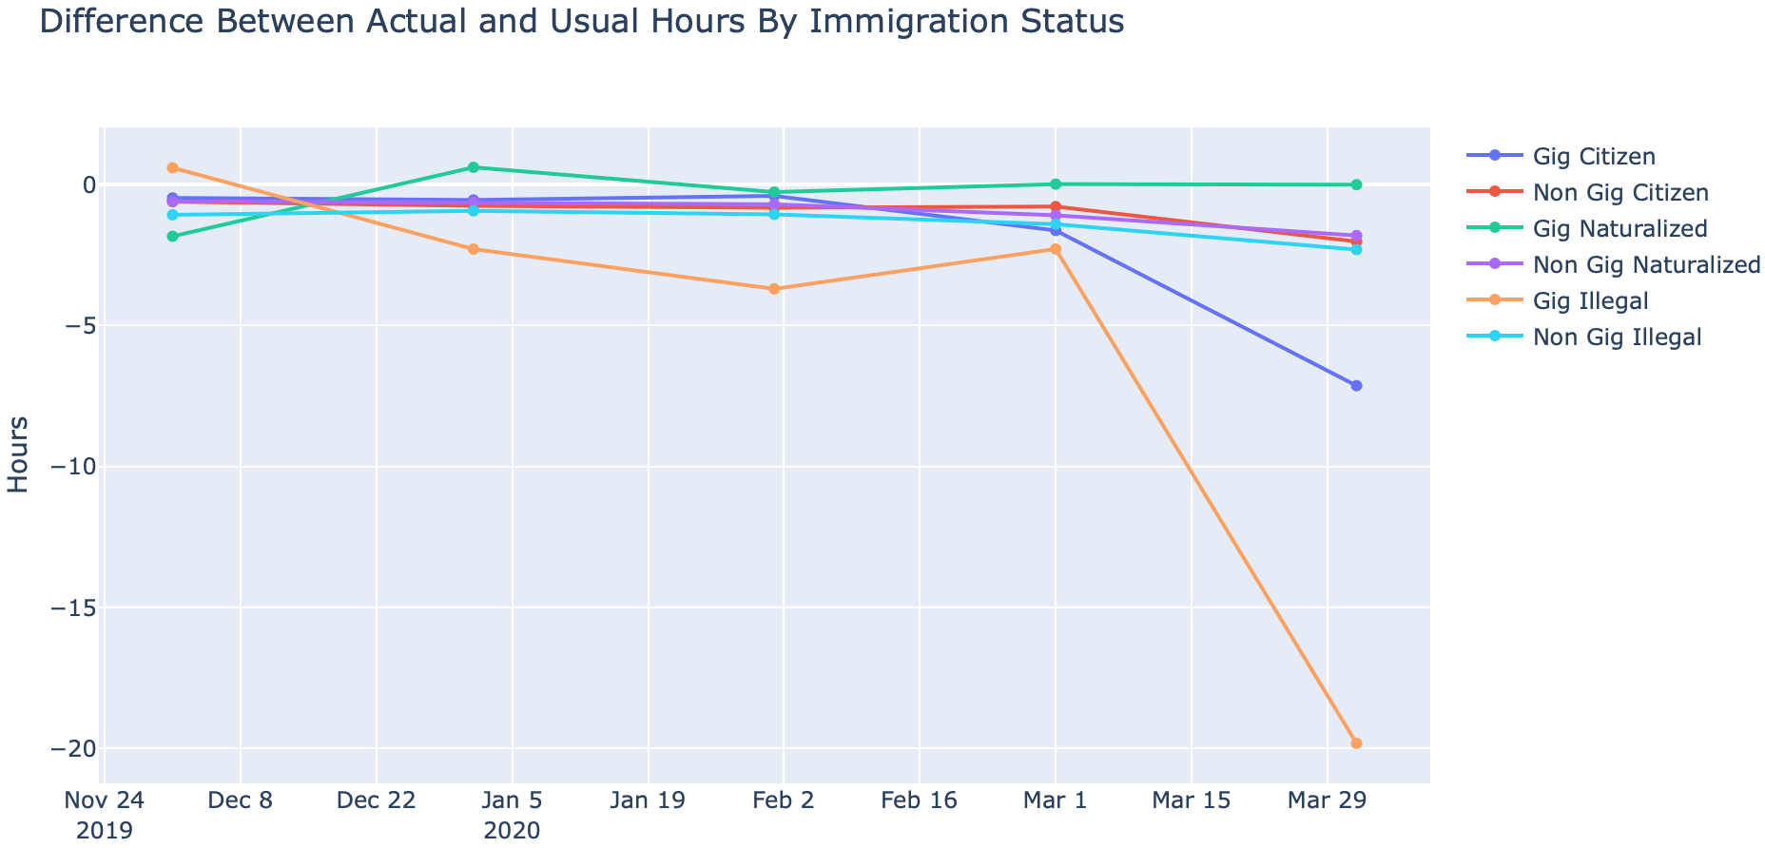

Using the second definition of part time workers illegal immigrant Gig workers are affected far more severely than any other group with Gig workers that are citizens also seeing significant reductions in hours worked of more than 5 hours from usual. The other groups saw relatively little impact on their hours worked with naturalized Gig workers faring the best in this case, ending March working as many hours as expected. There are 381 Gig workers that are citizens, 13 that are naturalized, and 14 that are illegal immigrants compared to 50,738 non Gig workers that are citizens, 3,318 that are naturalized, and 3,312 that are illegal immigrants.

Definition 3 (multiple jobs)

As was the case with part time workers, when considering Gig workers as those with multiple jobs illegal immigrants saw significantly greater reductions in hours worked while citizens and naturalized Gig workers experienced significant losses as well. In this case there are 1,602 Gig workers who are citizens, 111 who are naturalized, and 67 who are illegal immigrants. Then there are 49,517 non Gig workers who are citizens, 3,220 who are naturalized, and 3,259 that are illegal immigrants.

Gender

Definition 1 (Self employed not incorporated)

Male and female Gig workers see similar impacts on their hours worked and as expected consistently greater reductions in hours than non Gig workers. Both groups experienced slight rebounds but March proved to be destructive to their hours worked seeing a serious widening in the disparity between usual and actual hours worked. There are 1,106 male Gig workers and 716 females compared to 26,879 male non Gig workers and 29,097 female.

Definition 2 (Part time)

Taking the part time definition of Gig workers males are gradually affected by the pandemic finishing March with a roughly 6 hour discrepancy between usual and actual hours worked. Female Gig workers on the other hand had a similar trajectory until March where the number of hours worked dropped off sharply. There are 147 male Gig workers and 261 females, while the sample has 27,838 male non Gig workers and 29,552 females.

Definition 3 (multiple jobs)

The effect on female Gig workers is relatively consistent for each definition of Gig workers with a modest reduction in hours from usual each month until March where this group saw significant drops in hours worked. The male Gig workers under this definition saw a similar impact to those under the first definition with the same modest reduction in hours as the females until March where they saw a more drastic loss of work. There are 844 male Gig workers and 939 females while there are 27,141 male non Gig workers and 28,874 females.

Marital Status

Definition 1 (Self employed not incorporated)

Under the first definition of self-employed not incorporated, single and married Gig workers saw very similar fallout from the pandemic with respect to hours worked while separated/dicvorced Gig workers managed to lose fewer hours until March where they were impacted more severely than the other Gig worker groups. There are 328 separated/divorced/widowed Gig workers, 1,200 married, and 326 single while there are 8,668 separated/divorced/widowed non Gig workers, 23,775 married, and 13,916 single.

Definition 2 (part time)

Taking part time workers as Gig workers, separated/divorced/widowed Gig workers experienced a significant rebound in February that was met by an even greater decrease in March as they finished the month working 13 hours fewer than usual. Married Gig workers had a similar impact from the virus in March but were more consistent from December to February with only a slight reduction in hours worked from usual. Single Gig workers were impacted similar to married Gig workers again seeing consistent impacts until March where the effects grew more significant. There are 60 separated/divorced/widowed Gig workers, 190 that are married, and 162 that are single. For non Gig workers, 8,936 are separated/divorced/widowed, 24,785 are married, and 14,080 are single.

Definition 3 (multiple jobs)

Taking those with multiple jobs as Gig workers sees separated/divorced/widowed Gig workers again as the most adversely affected despite another rebound in February. Married and single Gig workers had very similar impacts throughout the sample and were also severely affected by the virus in March. There are 310 separated/divorced/widowed Gig workers in the sample, 989 married, and 504 single compared to 8,686 separated/divorced/widowed non Gig workers, 23,986 married, and 13,738 single.